

JOB APPLICATION PACK

www.mawwfire.gov.uk

Introduction
Dear Applicant,

Thank you for your interest in joining Mid and West Wales Fire and Rescue Service.
My vision is for our Service ‘To deliver the best possible service for the communities of Mid and West Wales.’ Whilst we have a proud track record of achievement, we know that there is always room for improvement.

When people think of a career in the Fire and Rescue Service, they tend to think of Firefighters responding to emergency incidents, but it’s not just Firefighters who make mid and west Wales a safer place.

Behind the operational scene, the Service has a large range of other posts within different departments which are either office based or in our workshops, and we employee people in professional, technical, and administrative roles.

Without corporate support functions in place to provide the systems, processes and technology, the Service would not be able to deliver the best possible service to our communities.

If you’re looking for a career with variety, a challenge, and opportunities for progression, along with all the benefits you’d expect from a key public service organisation, then why not consider joining us in one of our specialist or administrative support functions.
Thank you and good luck
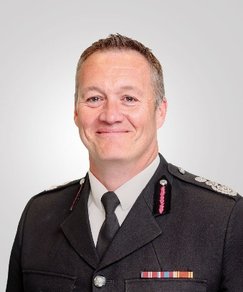



Craig Flannery
Chief Fire Officer

Job Application Pack

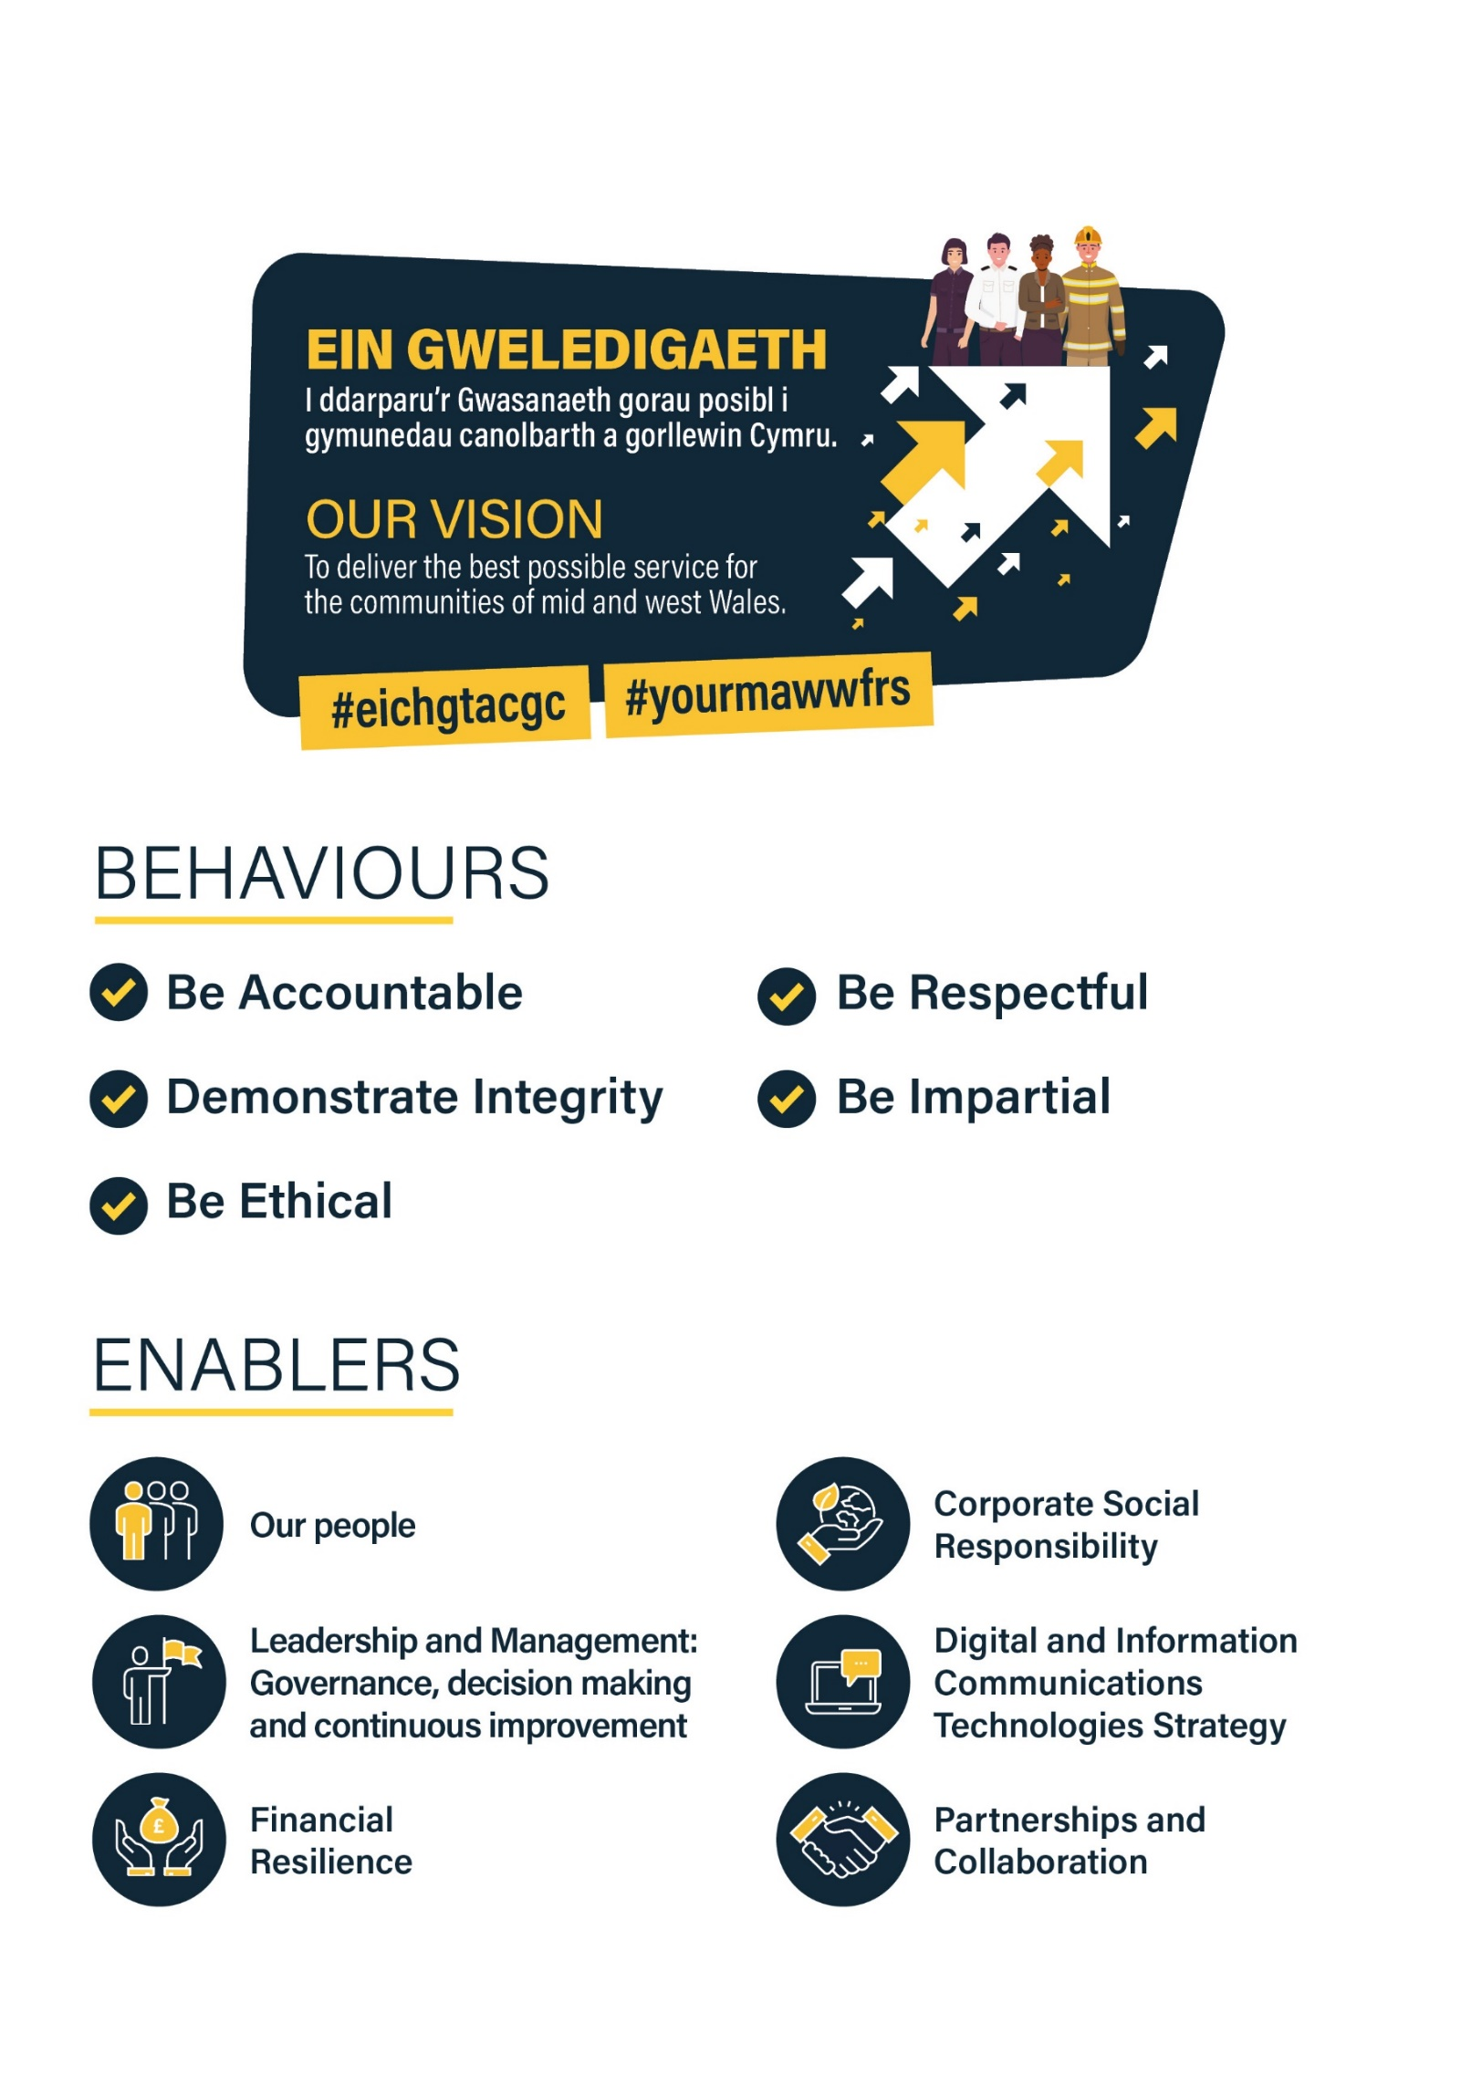

Job Application Pack

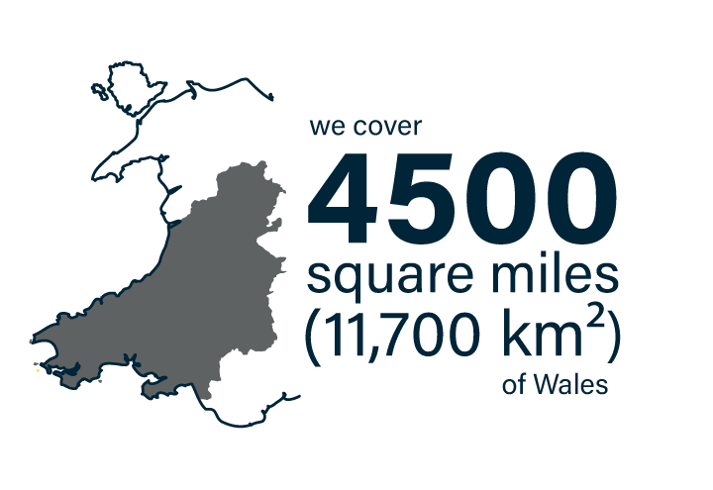
About the Service

The Service was created in 1996 by the Local Government (Wales) Act 1994, following the merger of Dyfed, Powys and West Glamorgan Fire Brigades Mid and West Wales Fire and Rescue Service covers the following County Council areas:



The Service makes up almost two-thirds of Wales, covering a predominantly rural area of 11,700 km² (4,500 square miles), with 650km of coastline. With its Headquarters in Carmarthen, the Service employs 1300 staff, with a little over a 1100 of those based
in one of 58 stations spread across three Divisions. The Service has the third highest population sparsity in England and Wales and there are 900,000 people that live within our Service area. This number increases to over 2 million as a result of tourism through the summer months.
It is the third geographically largest Fire and Rescue Service in the United Kingdom, behind the Scottish and Northern Ireland Fire and Rescue Services. This in itself presents a range of different challenges.
There are a variety of risks found within the Service area, ranging from the petrochemical industries in Milford Haven, to the risks associated with heavily populated areas such as Swansea and Neath Port Talbot. There is also a large farming community and many other light industries throughout the area.
These, together with an extensive coastline and inland waterways, form some of the specialised risks found within the Service.
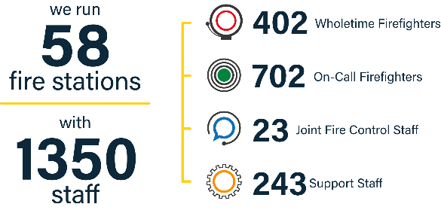
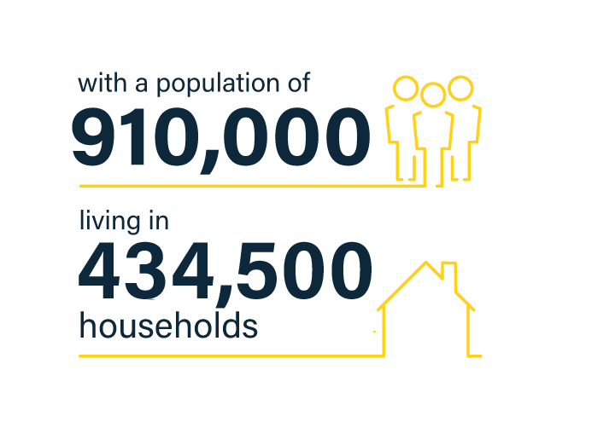

Benefits

Working for the Service opens the door to a whole portfolio of benefits which can enhance your lifestyle both now and into the future.


Competitive rates of pay -
recently reviewed to ensure fairness across all roles; with annual increments to the top of your salary band, as you build knowledge and experience.


Local Government Pension scheme -
A generous pension scheme, with the Service making a substantial contribution (currently 15.2%) to funding your retirement, as well as the option to increase your benefits by purchasing additional pension or investing in Additional Voluntary Contributions (AVC).


Generous Annual leave –
26 Days plus bank holidays, going up to 33 days after 5 years employment.


Flexi Scheme –
Opportunity to flex your working hours to help accommodate life outside of work.

- Access to Blue Light Card discount scheme

Free on-site parking Cycle to Work Staff Discount scheme Health and Wellbeing
- Car Leasing Salary Sacrifice scheme
- Let’s Connect IT equipment loan scheme
- Subsidised canteen facilities
- Sports and Social Club
- Firefighters Charity

A Working Environment Shaped by our Values

Committed to Equality and Diversity -
Equality, diversity and inclusion is at the heart of what we do as a Service and are values which sit at the core of our organisational processes, practices and culture.

As a service, we are committed to identifying, understanding, and eliminating all barriers that prevent access to services, information, and employment.

The Service currently has a small number of internal employee networks / forums in place, which play an active role in:

- Championing issues for employees;
- Contributing to the organisation’s diversity and inclusion agenda;
- Advising on policy development;
-
- Improving the work environment for employees

Committed to reducing our Environmental Impact
We recognise that our operations have an effect on the global and local environment and are committed to minimising adverse environmental impacts within financial, operational and resource constraints.

In our race to Net Zero Carbon Status by 2030, the Service has set itself targets that align with the Welsh Government route map for decarbonisation across the Welsh public sector.

The Service has achieved Level 5 Green Dragon Environmental Standard accreditation for the 8th year in a row.

Job Profile

Salary: Grade 8 - £ 37,280 - £39,152 (+12% for being conditioned to the flexible staffing model, see below).
ABOUT THIS JOB

Mid and West Wales Fire and Rescue Service is seeking applications from individuals for the role of Driving Instructor within the Training Delivery Department and will work across service to suit business need, however primarily in Western Division (Carms & Pembs) Base location Carmarthen.

The Role

The successful candidate will deliver the Driver Training provision for the Service, ensuring that all training and learning conforms to Health and Safety at Work Act and other legislative requirements.

This is a full-time post working 37 hours per week.

Please Note: Post holder will be conditioned to a flexible staffing model and will be required to deliver ERD initial courses up to a maximum of 8 courses per year. This will require a 42.5 hour/week for up to 16 weeks per year with some evening and weekend working.

Post holders will receive an additional 12% on their salary for working the flexible staffing model system. For further details please contact the Lead Driver Instructor.

Enquiries
For further information regarding this post, please contact Lead Driving Instructor Gerald Thomas gb.thomas@mawwfire.gov.uk

Job Description

TITLE OF POST: | Driving Instructor
RANK/ROLE: | Grade 8
POST REFERENCE:
LOCATION: | Will work across service to suit business need, however primarily in Western Division (Carms & Pembs) Base location Carmarthen/Haverfordwest
RESPONSIBLE TO: | Lead driving instructor
MAIN PURPOSE OF JOB: | To deliver Driver Training provision for the Service, ensuring that all training and learning conforms to Health and Safety at Work Act and other legislative requirements.

SCHEDULE OF RESPONSIBILITIES RESPONSIBLE TO

Deliver Initial LGV driver training inline with relevant Service policies ensuring compliance with all appropriate Health and Safety regulations, to DVSA standards. | Lead driving instructor
Deliver Initial PCV driver training in line with relevant Service policies ensuring compliance with all appropriate Health and Safety regulations, to DVSA standards. | Lead driving instructor
Deliver Emergency Response Driver Training (ERDT) (Initial and Assessment) inline with relevant Service policies ensuring compliance with all appropriate Health and Safety regulations and legislative requirements. | Lead driving instructor
Deliver Light Vehicle ERDT (Category B vehicles e.g. Car, Landrover etc.) training (Initial and Assessment) inline with relevant Service policies ensuring compliance with all appropriate Health and Safety regulations and legislative requirements | Lead driving instructor
Deliver 4 x 4 Off-Road driver training inline with relevant Service policies ensuring compliance with all appropriate Health and Safety regulations. | Lead driving instructor
Carry out Vehicle Driving Assessments and identify remedial training for any driver, including drivers with identified training needs. Give verbal feedback and prepare written reports as necessary. | Lead driving instructor
Deliver Specialist driver training (Forklift, HVP, RO-RO, Brimec Lorry Mounted Crane, Winch and Drop-body) inline with relevant Service policies ensuring compliance with all appropriate Health and Safety Regulations | Lead driving instructor
Complete end of course reports and training returns | Lead driving instructor
Maintain a detailed breakdown of all driver training and related training that has been carried out | Lead driving instructor
Attend appropriate training courses and seminars in support of the role of Service Driving Instructor (police, Off Road etc). | Lead driving instructor

Carry out daily and weekly (A&B) vehicle routines on all training vehicles and report any defects. Liaise with Workshops on vehicle maintenance requirements. Ensure that training appliances are always maintained in a presentable condition. | Lead driving instructor
Complete paperwork for pay claims for delegates and for yourself and forward to Driver Training / Assessment Manger. | Lead driving instructor
In liaison with Human Resources, ensure that the Authority satisfies its obligations to provide LGV medicals for appropriate categories of employees. | Lead driving instructor
In conjunction with the Heads of Response and the Lead driving instructor, plan and programme current and future driver training needs (initial and refresher, inc. ERDT) of the Service. This is to include Light Vehicle, LGV, 4X4, Special Appliances including towing of trailers. | Lead driving instructor
To act as liaison officer between the D.V.S.A. and the Service, enabling up to date legislation, working practices and training policies to be maintained. | Lead driving instructor
To ensure that the delivery of driver training is monitored to ensure quality of delivery | Lead driving instructor
When appropriate, occasionally carry out identified training/examining to suit Service requirements (out of normal hours during evenings and/or weekends) | Lead driving instructor
Post holder will be required to complete a Level 3 Award in Assessing Competence in the Work Environment and Level 3 Award in Education and Training. | Lead driving instructor
Commit to safeguarding and promoting the welfare of children, young people, and adults at risk of abuse and or neglect in the wider communities by reporting concerns to the Services Safeguarding Officer and/or Safeguarding Team. | Safeguarding Officer and/or Safeguarding Team.



MID AND WEST WALES FIRE AND RESCUE SERVICE
PERSON SPECIFICATION

POST TITLE | Driving Instructor
LOCATION | Will work across service to suit business need, however primarily in Western Division (Carms & Pembs)
POST NUMBER
GRADE | 8
DEPARTMENT | Operational Support & Improvement – Training Delivery
DBS CHECK | Standard

Please ensure you address each of the following requirements in your Application Form as they will be used for shortlisting purposes. You should provide clear evidence that demonstrates you meet each area based on your skills, knowledge, experience and abilities relevant to the post.

Factor | Evidence | Essential/ Desirable | Assessment Method
Qualifications | High personal level of Driving Skills (LGV)  LGV Licence minimum 3 years  Category ‘C’ LGV Driving Instructor  Category ‘C + E’ LGV Driving Instructor  Category D1  DVSA Approved Driving Instructor (ADI)  ERDT Driving Instructor  Off Road 4x4 Instructor  Response Driver  Other specialist driver training (Forklift, Hook lift, HIAB etc)  Hold a recognised assessor qualification  H&S qualifications (NEBOSH/IOSH)  Note: The post-holder will be expected to become qualified and demonstrate competence in each of the above areas plus other subjects not identified but which are/will be deemed (by the Head of Operational Learning & Core Skills) to be commensurate with the role and job description. | Essential*  Essential*  Essential*  Essential*  Desirable  Desirable  Desirable  Desirable  Desirable  Desirable  Desirable  Desirable | Application form and Interview
Knowledge | Be able to demonstrate a high personal level of driving skills (LGV)  Be able to demonstrate skills as a Category ‘C’ LGV Driving Instructor  Be able to demonstrate skills as a Category ‘C + E’ LGV Driving Instructor  Be able to demonstrate skills as a DVSA Approved Driving Instructor (ADI)  Be able to demonstrate skills as a ERD Driving Instructor  Be able to demonstrate skills as an Off Road 4x4 Instructor  Be able to demonstrate skills as a Response Driver | Essential*  Essential*  Desirable  Desirable  Desirable  Desirable  Desirable | Application form and Interview

Experience | Have a minimum of 2 years experience as an LGV Driving Instructor  Have experience as a Driving Instructor on vehicles other than LGV.  Have a minimum of 2 years’ experience as a D1 Driving instructor | Essential*  Essential*  Desirable | Application form and Interview
Job Related / Personal Skills | Have an understanding of the issues facing the delivery of Training/Assessment to personnel working a variety of duty systems and the impact of Section 19 on the Service  Have an understanding of the demographic challenges within MWWFRS and the implications for the delivery of Driver Training.  Well developed interpersonal skills, consistent with modern working practices.  An objective and rational approach to decision making and problem solving.  Evidence of workload prioritisation and adapting to meet required deadlines.  Be flexible with work patterns, in order to deliver organisational objectives subject to section 19 requirements.  Understanding the aims and objectives in line with Service values and mission statement.  The post holder must be prepared to undertake relevant training courses in order to become multi-skilled.  The post holder must be willing to deliver Training/Assessment at other locations; away from their normal place of work (this may involve being away overnight/s).  Be able to evidence continuous personnel development. | Essential*  Essential*  Essential*  Essential*  Essential*  Essential*  Essential*  Essential*  Essential*  Essential* | Application form and Interview
Communication | Able to communicate effectively both verbally and in writing, having the ability to demonstrate professional credibility.  The effective use of ICT systems (Outlook/ Teams) to facilitate recording of all training activities. | Essential*  Essential* | Application form and Interview

In line with the Service’s Recruitment and Selection procedure, a standard disclosure is required as a minimum for all roles.

Certain roles will be subject to increased levels of DBS check, dependent on the duties and responsibilities of the role, and as designated by the relevant Head of Command or Department.

Where a requirement for a higher level of DBS check has been identified the level and justification for this is specified below:
LEVEL: Standard
JUSTIFICATION:..............................................................................................................................................
PREPARED BY:
DATE REVIWED:

How to Apply

Closing Date: 15 May 2026

The information provided on the application form is key information that will be used in the short listing process. It is therefore important that the guidance notes below are followed when completing the application form. This will ensure all the relevant information is available to make a decision on whether you will be short listed for
interview. Short listing will involve assessment of the details provided on the application form against the criteria outlined in the Person Specification provided.

Applications will be accepted in other formats where an applicant has difficulty completing the standard form as a result of disability.

What happens after you’ve sent in your application?

Once we’ve received your application, we will separate the equal opportunities monitoring form which will not form part of the selection process and will send the application form only to the shortlisting department. We will send an acknowledgement of receipt to all applicants.
Your application will then be assessed against the criteria (in a person specification) and the shortlisting panel will decide whether it can be shortlisted.
If you are not shortlisted for interview, you will be advised in writing, usually within six weeks of the closing date. If you have not heard from us by then, please contact us.
If you are shortlisted for interview, you will receive an email from us usually within 2-3 weeks of the closing date, advising the date, time and location of the interview. The email will also include details of assessment testing which is to be carried out and will continue the documentation which you are required to bring with you, if applicable to the role.





www.mawwfire.gov.uk

