


JOB APPLICATION PACK

www.mawwfire.gov.uk

Introduction
Dear Applicant,

Thank you for your interest in joining Mid and West Wales Fire and Rescue Service.
My vision is for our Service ‘To deliver the best possible service for the communities of Mid and West Wales.’ Whilst we have a proud track record of achievement, we know that there is always room for improvement.

When people think of a career in the Fire and Rescue Service, they tend to think of Firefighters responding to emergency incidents, but it’s not just Firefighters who make mid and west Wales a safer place.

Behind the operational scene, the Service has a large range of other posts within different departments which are either office based or in our workshops, and we employee people in professional, technical, and administrative roles.

Without corporate support functions in place to provide the systems, processes and technology, the Service would not be able to deliver the best possible service to our communities.

If you’re looking for a career with variety, a challenge, and opportunities for progression, along with all the benefits you’d expect from a key public service organisation, then why not consider joining us in one of our specialist or administrative support functions.
Thank you and good luck
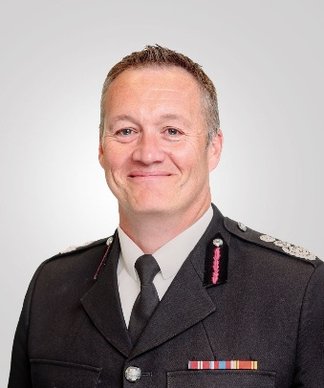



Craig Flannery
Chief Fire Officer

Job Application Pack

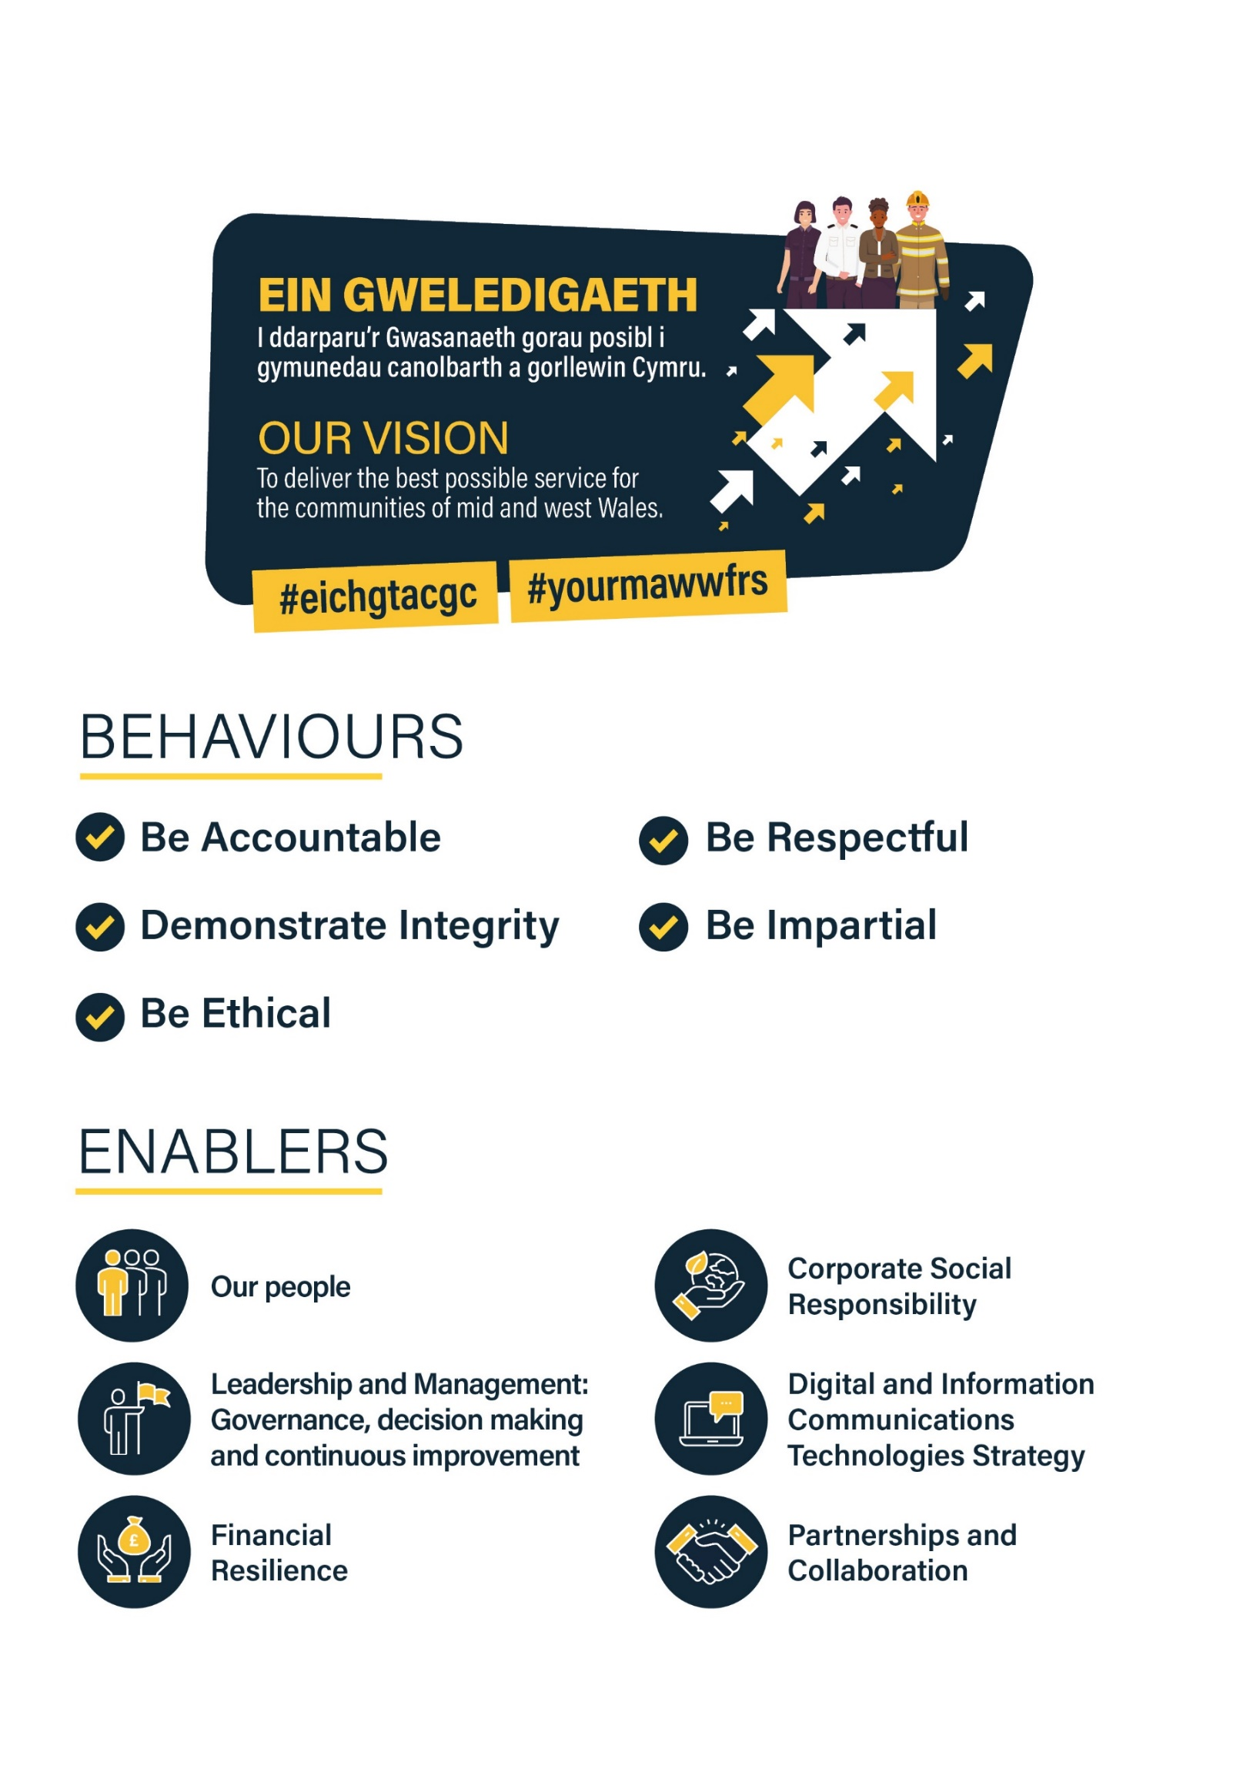

Job Application Pack

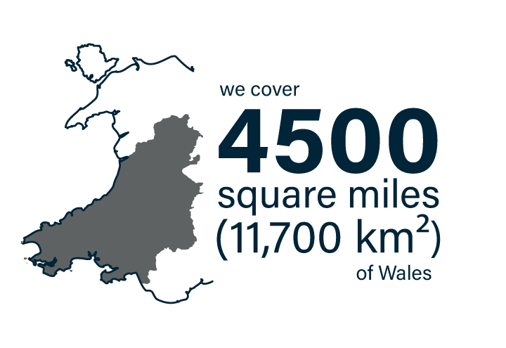
About the Service

The Service was created in 1996 by the Local Government (Wales) Act 1994, following the merger of Dyfed, Powys and West Glamorgan Fire Brigades Mid and West Wales Fire and Rescue Service covers the following County Council areas:



The Service makes up almost two-thirds of Wales, covering a predominantly rural area of 11,700 km² (4,500 square miles), with 650km of coastline. With its Headquarters in Carmarthen, the Service employs 1300 staff, with a little over a 1100 of those based
in one of 58 stations spread across three Divisions. The Service has the third highest population sparsity in England and Wales and there are 900,000 people that live within our Service area. This number increases to over 2 million as a result of tourism through the summer months.
It is the third geographically largest Fire and Rescue Service in the United Kingdom, behind the Scottish and Northern Ireland Fire and Rescue Services. This in itself presents a range of different challenges.
There are a variety of risks found within the Service area, ranging from the petrochemical industries in Milford Haven, to the risks associated with heavily populated areas such as Swansea and Neath Port Talbot. There is also a large farming community and many other light industries throughout the area.
These, together with an extensive coastline and inland waterways, form some of the specialised risks found within the Service.
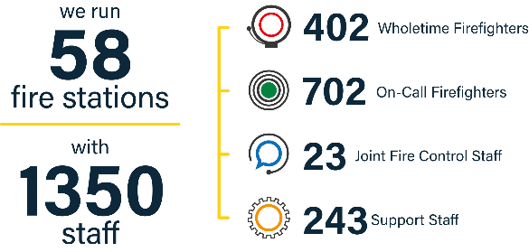
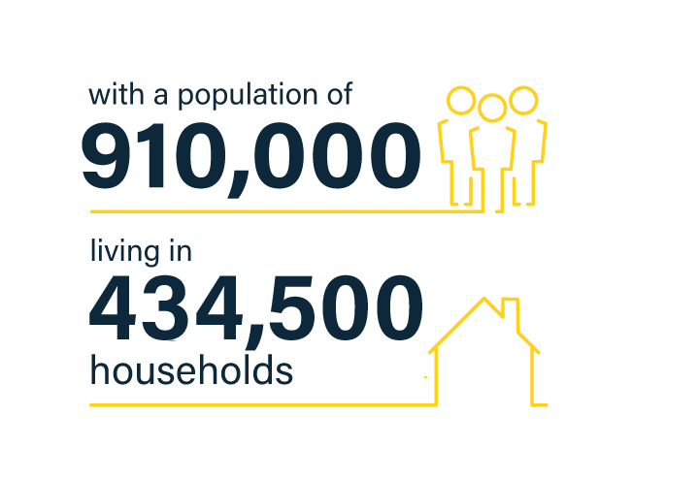

Benefits

Working for the Service opens the door to a whole portfolio of benefits which can enhance your lifestyle both now and into the future.


Competitive rates of pay -
recently reviewed to ensure fairness across all roles; with annual increments to the top of your salary band, as you build knowledge and experience.


Local Government Pension scheme -
A generous pension scheme, with the Service making a substantial contribution (currently 15.2%) to funding your retirement, as well as the option to increase your benefits by purchasing additional pension or investing in Additional Voluntary Contributions (AVC).


Generous Annual leave –
26 Days plus bank holidays, going up to 33 days after 5 years employment.


Flexi Scheme –
Opportunity to flex your working hours to help accommodate life outside of work.





- Access to Blue Light Card discount scheme

Free on-site parking Cycle to Work Staff Discount scheme Health and Wellbeing
- Car Leasing Salary Sacrifice scheme
- Let’s Connect IT equipment loan scheme
- Subsidised canteen facilities
- Sports and Social Club
- Firefighters Charity

A Working Environment Shaped by our Values

Committed to Equality and Diversity -
Equality, diversity and inclusion is at the heart of what we do as a Service and are values which sit at the core of our organisational processes, practices and culture.

As a service, we are committed to identifying, understanding, and eliminating all barriers that prevent access to services, information, and employment.

The Service currently has a small number of internal employee networks / forums in place, which play an active role in:

- Championing issues for employees;
- Contributing to the organisation’s diversity and inclusion agenda;

- Advising on policy development;
-
- Improving the work environment for employees

Committed to reducing our Environmental Impact
We recognise that our operations have an effect on the global and local environment and are committed to minimising adverse environmental impacts within financial, operational and resource constraints.

In our race to Net Zero Carbon Status by 2030, the Service has set itself targets that align with the Welsh Government route map for decarbonisation across the Welsh public sector.

The Service has achieved Level 5 Green Dragon Environmental Standard accreditation for the 8th year in a row.

Job Profile

Salary: £29,540- £31,022 pro rata
ABOUT THIS JOB

The Legal Administrator will be responsible for carrying out administrative tasks and providing support to the Business Fire Safety Department.

This role involves preparing documents and reports for the Criminal Justice System, ensuring records are maintained in line with policy and liaising with departments and Courts, providing information as needed.

The ideal candidate will be a confident communicator, experienced in administration tasks using Microsoft IT packages, and have good attention to detail.

Job Description

TITLE OF POST: | Legal Administrator
RANK/ROLE: | Grade 5
POST REFERENCE: | ADM.057
LOCATION: | Service Headquarters, Carmarthen
RESPONSIBLE TO: | Station Manager
MAIN PURPOSE OF JOB: | - Prepare, administer and deliver legal correspondence and associated materials relevant to the CRR department to ensure compliance with the requirements of the Criminal Justice System.  - Provide resilience to the Fire Safety Order Administrator and Building Regulations Administrator and other CRR roles.

SCHEDULE OF RESPONSIBILITIES RESPONSIBLE TO

Legal & Compliance Administration  - Maintain the security of all departmental correspondence, documents, records, IT systems and other such materials to ensure compliance with statutory obligations and the requirements of the Criminal Justice System. | Station Manager (Legal & Policy Officer)
- Administer digital imagery in accordance with the Service’s and nationally recognised protocols, policies & procedures to ensure compliance with the requirements of the Criminal Justice System. | Station Manager (Legal & Policy Officer)
- Assist in the preparation, administration and delivery of Service documents to meet organisational requirements | Station Manager (Legal & Policy Officer)
- Assist in the preparation, administration and delivery of legal bundles to ensure compliance with the requirements of the Criminal Justice System. | Station Manager (Legal & Policy Officer)
- Assist in the preparation of schedules of costs. | Station Manager (Legal & Policy Officer)
- Liaise with other Service departments as and when necessary to administer requests from external bodies in accordance with Service policies & procedures. | Station Manager (Legal & Policy Officer)
- Provide reports and other such information to external bodies e.g. Police, CPS, other regulators etc. in accordance with | Station Manager (Legal & Policy Officer)
- Maintain internal register to support the requirements of Fire Investigation, Business Fire Safety and Community Safety personnel. | Station Manager (Legal & Policy Officer)

- Maintain external registers to ensure compliance with statutory and non-statutory obligations on the Service. | Station Manager (Legal & Policy Officer)
- Liaise with Courts e.g. Magistrates, Crown, Coroners etc. to provide information they may require and also to make such enquiries to allow the Service and/or Service personnel to meet obligations to the Criminal Justice System. | Station Manager (Legal & Policy Officer)
- Correspond with the Service’s Legal Counsel under licensed access as and when necessary to meet business needs | Station Manager (Legal & Policy Officer)
- Attend meetings associated with the Legal & Compliance function and provide necessary administrative support. | Station Manager (Legal & Policy Officer)
CRR Resilience  - To provide primary resilience to the Building Regulations Administrator (See Building Regulations Administrator job description for details | Station Manager (Delivery)
- To provide secondary resilience to the CRR Software Administrator (See CRR Software Administrator job description for details | Station Manager (Delivery)
- To provide tertiary resilience to other CRR support roles | Station Manager (Delivery)
CRR Administration  - Supply administrative support to members of the CRR department | CRR Officer
- Requisitioning and associated administration of orders using Agresso | CRR Officer
- Use all office machinery and equipment including personal computing systems and photocopier. | CRR Officer
- Typing and word processing | CRR Officer

- Recording and writing up minutes of meetings | CRR Officer
- Maintenance of spreadsheets | CRR Officer
- Scanning of documents | CRR Officer
- Paper and electronic filing | CRR Officer
- Data input and maintenance of department records | CRR Officer
10) Maintaining departmental resources | CRR Officer
11) Sort and process incoming and outgoing mail | CRR Officer
12) Maintain and update electronic calendars | CRR Officer
13) Monthly vehicle returns. | CRR Officer
Training & Development  - Undertake personal training as is necessary to facilitate the role and assist in the development of others. | Head of Business Fire Safety



MID AND WEST WALES FIRE AND RESCUE SERVICE
PERSON SPECIFICATION

POST TITLE | Legal Administrator
LOCATION | Service Headquarters, Carmarthen
POST NUMBER | ADM.057
GRADE | 5
DEPARTMENT | Business Fire Safety
DBS CHECK | Standard

Please ensure you address each of the following requirements in your Application Form as they will be used for shortlisting purposes. You should provide clear evidence that demonstrates you meet each area based on your skills, knowledge, experience and abilities relevant to the post.

Factor | Evidence | Essential/ Desirable | Assessment Method
Qualifications | A-Level English  5 GCSE’S to include English and Maths  RSA Stage 1/11 Typing/Word processing Qualification  Recognised legal qualification such as City & Guilds / ILEX Level 3 Diploma for Legal Secretaries. (Post holder will be expected to acquire this qualification) | Desirable  Essential*  Desirable  Desirable | Application form and Certificates
Knowledge | Knowledge of Microsoft Word/Excel and various other software packages.  Regulatory Reform (Fire Safety) Order 2005.  Fire and Rescue Services Act 2004. | Essential*  Desirable  Desirable | Application form and Interview

Experience | Experience of day to day office activities  Experience of working in a legal environment such as a Court or solicitors office. | Essential*  Desirable | Application form and Interview
Job Related / Personal Skills | Ability to work to agreed strategies  Ability to work under pressure  Ability to work as part of a team  Ability to work on own initiative  Enthusiastic and committed approach to providing a quality service.  Ability to respond effectively when working to deadlines  Proven ability to work to tight deadlines | Essential*  Essential*  Essential*  Essential *  Essential *  Essential*  Essential* | Application form and Interview
Communication | English verbal and written skills  - Must be able to communicate clearly and concisely with good oral comprehension  - Must be able to communicate information clearly and legibly in a well presented format with a good standard of comprehension.  - Must be able to proof read a document and deal with spelling and grammatical issues.  Welsh verbal and written skills Level 1  Good interpersonal skills | Essential*  Essential*  Essential*  Essential* | Application form and Interview

In line with the Service’s Recruitment and Selection procedure, a standard disclosure is required as a minimum for all roles.

Certain roles will be subject to increased levels of DBS check, dependent on the duties and responsibilities of the role, and as designated by the relevant Head of Command or Department.

Where a requirement for a higher level of DBS check has been identified the level and justification for this is specified below:
LEVEL:....STANDARD..........................................................................................................................................
JUSTIFICATION:..............................................................................................................................................
PREPARED BY:
DATE REVIEWED:

How to Apply

Closing Date: 13 May 2026

The information provided on the application form is key information that will be used in the short listing process. It is therefore important that the guidance notes below are followed when completing the application form. This will ensure all the relevant information is available to make a decision on whether you will be short listed for
interview. Short listing will involve assessment of the details provided on the application form against the criteria outlined in the Person Specification provided.

Applications will be accepted in other formats where an applicant has difficulty completing the standard form as a result of disability.

What happens after you’ve sent in your application?

Once we’ve received your application, we will separate the equal opportunities monitoring form which will not form part of the selection process and will send the application form only to the shortlisting department. We will send an acknowledgement of receipt to all applicants.
Your application will then be assessed against the criteria (in a person specification) and the shortlisting panel will decide whether it can be shortlisted.
If you are not shortlisted for interview, you will be advised in writing, usually within six weeks of the closing date. If you have not heard from us by then, please contact us.
If you are shortlisted for interview, you will receive an email from us usually within 2-3 weeks of the closing date, advising the date, time and location of the interview. The email will also include details of assessment testing which is to be carried out and will continue the documentation which you are required to bring with you, if applicable to the role.





www.mawwfire.gov.uk

